Alexis Elder
George Foundation Youth-in-Philanthropy
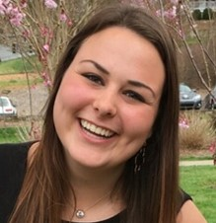
As a junior in high school, Alexis Elder didn’t understand what the word “philanthropy” meant. Now a sophomore at the University of North Carolina, a member of Youth Philanthropy Connect’s Leadership Team, alumnus of Youth in Philanthropy, and a recent intern at the Greater Houston Community Foundation, Elder has an expert understanding of what “philanthropy” means.
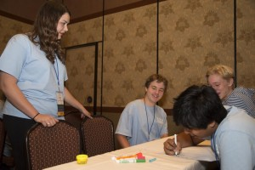
While Elder’s list of eclectic credentials on the philanthropy landscape in Houston is long, she brought her passion for giving to school as well. She took a Learning by Giving Foundation class her freshman year call Philanthropy as a Tool, in which Elder and 20 of her classmates created grant applications, developed an evaluation process, and granted $11,000 to three organizations in North Carolina.
Elder used her experience at school to guide her internship in Houston. “I’ve been able to help with creating grant applications—so basically everything my class did, I was able to do on my own with my own self-motivation and direction,” she said.
While her internship has ended and Elder is heading back to school, her passion for service work goes where ever she does. The biology and psychology major spends her time on campus in different service clubs, including Service in Leadership and a co-ed service fraternity for which she’ll be on the service committee. Alexis is staying engaged with the Greater Houston Community Foundation where she is on the inaugural teen leadership committee for the Family Giving Circle.
In terms of her work having a lasting impact, effective education reform is definitely on Elder’s to-do list. “Our education system is just really broken, especially in Texas,” she said. “I remember being in school and having programs that weren’t effective.” While the education system may be a delicate and intricate issue to tackle, Elder’s new exposure to youth leaders in the philanthropic field has reinstated a faith to address complex issues.
As a planning committee member, speaker, and session facilitator at the YPC 2016 International Conference, Elder was blown away at the impact of her work. “The conference was so well put together, and thinking that I was able to have such a big part in how well the conference was run—and so many people just complimenting us while we were there about how much they have learned and that they loved the work we were doing,” she said. “I really like that it’s not adults out there trying to address youth, but it’s youth addressing youth.”

