Alison Rae Pakradooni
Andrus Family Fund
When YPC Leadership Team member Ali Pakradooni works alongside relatives at the Andrus Family Fund (AFF), she meets different family members everyday. Being the largest family foundation in the country with over 400 members, gatherings can be eye-opening.
AFF is a next generation philanthropy program of the Surdna Foundation that seeks to advance the United States’ social justice movement and improve the lives of vulnerable youths.
Pakradooni started working with AFF when she joined the youth program at 13 years old. That’s when she started giving micro-grants to nonprofits in her area, and it’s also what sparked her interest in philanthropy. At 18 she joined the executive training board where she met with family members in New York throughout the year and learned how to write a request for proposals and review grants. That year of monthly conference calls cumulated in a pitch to the AFF board of a grant.
As a sophomore at Temple University, Pakradooni sits as the vice president of philanthropy on the executive board of her sorority. She’s hopeful that her passion for philanthropy will take her abroad to struggling areas to give medical assistance to people without healthcare. Even further in the future, she hopes to sit on the board of AFF. “I never really want to stop being involved in the family,” she said.
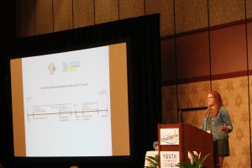
In her long-term philanthropic work, Pakradooni wishes to continue to serve underprivileged youth. “I have always felt that the youth need someone to fight for them …. So many children have such great aspirations and just need a little bit of guidance and assistance,” she said.
Pakradooni was introduced to YPC when she spoke at the Northeast regional gathering in New York last year. Afterward, she joined the Leadership Team and is now on the planning committee for the upcoming Northeast Gathering in Boston this fall. She said that her favorite parts of YPC gatherings are “definitely the different backgrounds, and perspectives, and lessons, and even the different levels of education.” Given the age gap on the Leadership Team (12- to 21-year-olds), Pakradooni said, “It’s just amazing to see all of us on the same team and doing the same level of work and involvement.”
“YPC has opened my eyes to so many things and all the great ways that the different learning programs from each individual all come together,” she said. “The more I’ve branched out, I can see small amounts of change.”

