Liam Fox
Frieda C. Fox Family Foundation Junior Board

To Liam Fox, giving isn’t just a way to help others—it’s a way to better one’s self.
As an Our Lady Malibu Catholic School sixth grader, Frieda C. Fox Family Foundation Junior Board member, and Youth Philanthropy Connect Leadership Team member, Fox’s amount of experience in philanthropy is unparalleled among his age group.
“Giving through the Frieda C. Fox Foundation, YPC, and the Leadership Team has changed me as a person and changed my look on the world,” Fox said.
As a first-year YPC Leadership Team member, eleven-year-old Liam appreciates the opportunity to converse with other youth philanthropists and share new ideas. He said he appreciates the moments of hearing other youth philanthropists speak and thinking to himself, “Oh, I never thought about that.”
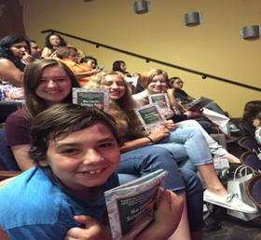
The Junior Board of the Foundation is able to makenominate and present individual grants to the board. This group of seven youth also grants collaboratively through an request for proposals (RFP) process to organizations supporting youth development in the Los Angeles region. These opportunities give Liam a unique perspective on giving, providing an opportunity to pursue his passion of helping youth. “My favorite part about being on the Junior Board of the Frieda C. Fox Family Foundation is that I get to learn about different groups that help kids,” he said.
While the Junior Board gives Liam a fulfilling chance to give other children opportunities that they would not otherwise have, a project that the young philanthropist feels very passionate about, the Leadership Team allows him to meet other young givers with different philanthropic goals. “I enjoyed collaborating with different philanthropists,” he said.
All of his philanthropic work has made Liam very grateful for the chance to make a difference. “Other people are not as fortunate as me,” he said. “By being on these [boards], they’ve given me wonderful opportunities and I’m really thankful because it’s changed me and I feel very different and very much like I’m making a change in the world.”

